Hickory Farms Community Association Strategic Plan

Our Vision
Hickory Farms offers its homeowners a good quality of life; providing and preserving the benefits of a safe, welcoming and diverse environment that sustains desirability and investment value for individual residents and the community.

Mission
The Hickory Farms Community Association (HFCA) will enhance and uphold quality of life and sense of community through effective and efficient management of the Association via compliance with the Deed of Dedication and Declaration of Covenants, Conditions, Rules and Regulations and By-laws. Hickory Farms will maintain-and improve property values. The Association will support initiatives and capital improvements that benefit the community. Resident volunteers will strive to restore, preserve and maintain the wildlife habitats in our common’s areas.

Values
- Equal opportunity for Community participation
- Respect for our Governing documents
- Integrity
- Transparency
- Inclusiveness
- Sense of community
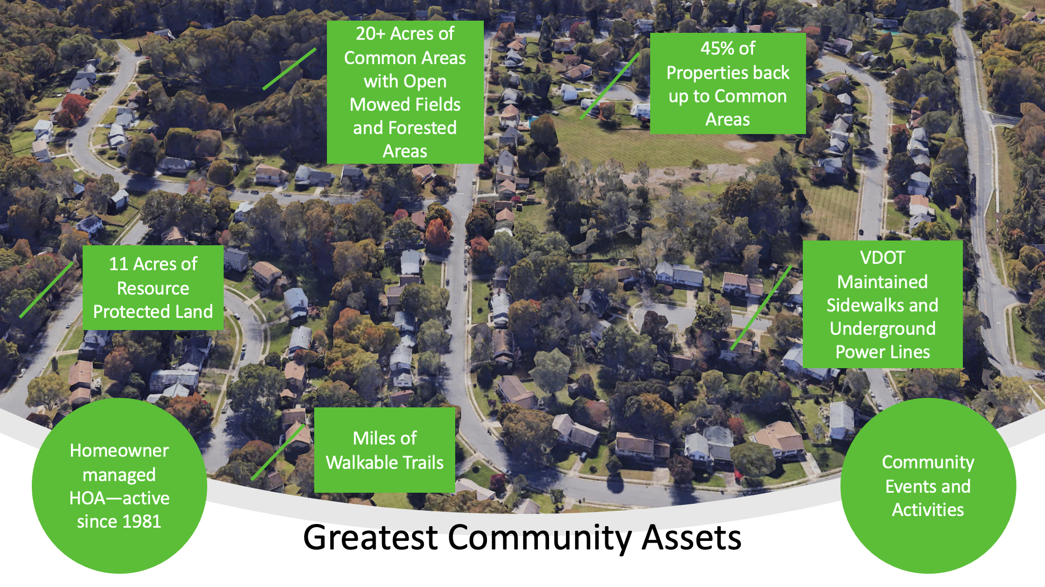
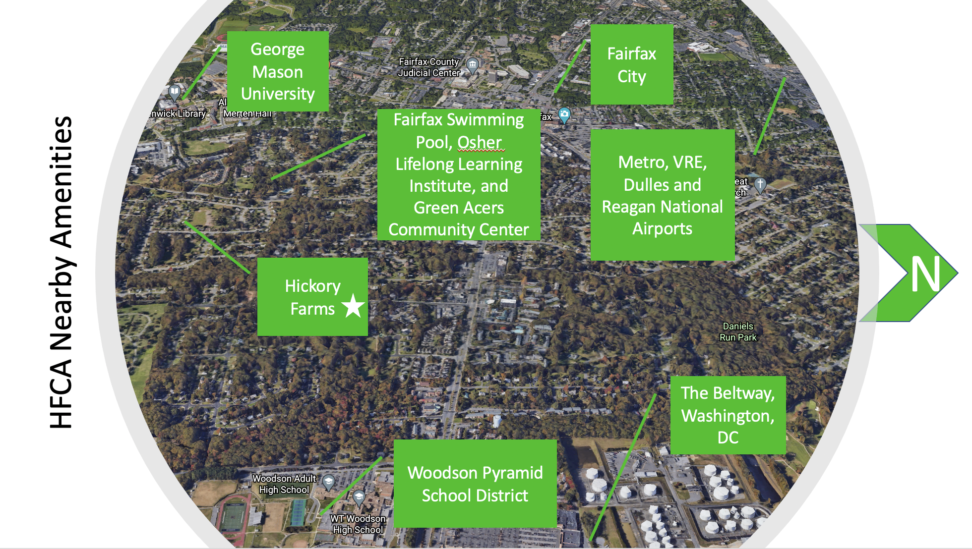

The Strategy

New Branding
The community plans to maintain a strategic branding process that is designed to leverage a community's strengths, raise its profile among target audiences, increase recognition and unify the community behind a consistent brand.
The Hickory Farms brand will be built on the positive perceptions of both current Association members and prospective buyers.

The Reserve Study
Providing for the repair and replacement of Association owned common assets is a process required by the Virginia Property Owner Association Act (VPOAA). The reserve study is an analysis of common area physical assets, estimated remaining useful life, current repair or replacement cost and development of an annual contribution amount to be added to the Reserve Fund each year to cover the cost of repair/replacement when required. A detailed study is conducted every 5 years with annual reviews each year between full studies for interim changes/modifications.

Sidewalks, curbs, roads and street safety
The Association plans to submit a request to VDOT on a regular basis on the status of our community’s sidewalks, curbs, roads, and streets to have them fixed and repaired when necessary.

Common Areas
In Hickory Farms, nature is a thriving part of the community. We need fresh air, clean
water and healthy habitats around us. We need places to relax and restore, and places to
develop connections with nature and with each other.

HFCA provides and manages these places for our community—with more than
20 acres of woodlands, creeks and meadows, nature trails and sustainable land.
Providing good experiences is the best way to cultivate lifestyles that have a positive
impact on personal and community health, and on the health of our land,
air, water and wildlife. This is done by restoration and management of diverse native habitats; by encouraging wildlife; by maintaining nature trails and green spaces for recreation and
meditation; and by offering educational information that fosters learning. This HFCA land cannot be developed.
- Upper Commons
As one of the most multidimensional areas, is comprised of mowed fields, wildflower meadows, tree groves, a historic American Boxwood grove with some visible remnants of the original Farm House of Hickory Farms and a bluebird trail. This location will be maintained to ensure that it is a safe place to relax and restore and develop connections with nature and with each other. This is done by restoration and management of diverse native habitats by encouraging wildlife; and by maintaining green spaces for recreation and meditation; and engaging with nature.
- Lower Commons
The Lower Commons is comprised of mowed fields, wildflower meadows, tree groves, paved path, and a bluebird trail. This location will be maintained to ensure that it is a safe place to relax and restore and develop connections with nature and with each other. Again, this is done by restoration and management of diverse native habitats by encouraging wildlife; and by maintaining green spaces for recreation and meditation; and engaging with nature.
- Northern Path
The Northern Path is our most used paved path. The path and area should be monitored and maintained to ensure useful life, safety, and continued steady use for many years to come.
- Rabbit Run Creek
Rabbit Run is a natural resource area and became a Resource Protection Area (RPA) in 2003.

Although there are some actions HFCA can take to protect this valuable habitat, many actions require Fairfax County approval and guidance, which guarantees that this land will remain an undeveloped nature preserve.

Communication
Communication is an ongoing activity for any organization that serves, depends upon, or is in any way connected with the community. The purpose, audience, message, and channels may change, but the need to maintain transparent communication with all 198-property owners.
The community plans to conduct an audit of the current forms of communication and identify any problem areas. Good communication starts with knowing and understanding your audience. Options include hosting a focus group or sending surveys to our community to determine the gaps in our current communication methods. Determine a few goals based on the data gathered from the results. Create and execute a plan.

The Architectural Control Committee
The mission of the Architectural Control Committee (ACC) is to assure that homeowners understand the obligation of homeownership in this community -and ultimately understand that what benefits the entire community also rewards each individual owner with potential gains in property value and enhanced quality of life.
At first sight, Hickory Farms will impress visitors with well-kept homes surrounding 20 acres of lush, inviting common areas -offering natural woodland, open lawn, and historic old growth areas. The ACC functions to maximize property values and support a superior quality of life in this exceptional environment.
Our governing documents – our Deed of Dedication and Declaration of Covenants, Conditions and Restrictions, By-Laws and Rules and Regulations -direct the Hickory Farms Homeowners Association (HFCA) to form a committee of at least four homeowners, including the Chair. All homeowners agree to adhere to these rules and community standards by signing and accepting the Virginia Property Owners Association Act (VPOAA) disclosure document they received at the purchase settlement. The ACC monitors adherence to these property owner rules.
The ACC enforces the Association’s Restrictive Covenants by requiring application and approval of all exterior changes and improvements, reviewing owner compliance through annual property inspections, generating violation notices, and evaluating all properties for violations prior to HFCA submitting the VPOAA disclosure documents for all resale settlements.
The ACC strives to remind homeowners of their legal obligation to comply with the rules of home maintenance in their community by periodically publishing and distributing the essential extractions of the Restrictive Covenants.
[Declarations, Article VII, Restrictive Covenants, Section 4]:
a) All lots and yards shall be maintained in a neat and attractive manner so as not to detract from the appearance of the Hickory Farms Community;
b) All dwellings shall be kept in good repair (e.g., shutters, trim, fences, siding, roof, etc.) and maintained in keeping with the standards of the neighborhood and development;
c) All curbs, driveways and sidewalks of lots shall be edged as needed to maintain a neat appearance and so that grass does not grow over curbs and sidewalks;
d) Flower beds and landscaping shall be maintained in an attractive manner so as not to detract from the appearance of the neighborhood or encroach on public and common areas.
Neighborhood Watch Program
The Association maintains an active neighborhood watch program, a group of people living in the same area who want to make their neighborhood safer by working together in conjunction with local law enforcement to reduce crime and improve their quality of life. Neighborhood Watch is homeland security at the most local level. It is an opportunity to volunteer and work towards increasing the safety and security of our homes and our homeland. Neighborhood watch empowers citizens and communities to become active in emergency preparedness, as well as the fight against crime and community disasters.
In the Neighborhood Watch program, volunteer residents slowly drive through the community during the evening and look out for suspicious activity. The car is marked with bright "Neighborhood Watch" signs. When the volunteers see something suspicious, they call 911 (this hardly ever happens). Volunteers do not exit the car during the patrol or confront troublemakers.
Neighborhood Watch helps keep Hickory Farms a safe and secure place to live. Law enforcement studies have shown that Neighborhood Watch communities have less crime than those that do not. Hickory Farms has had a Neighborhood Watch program since 1982.

Social Committee
The Social Committee will engage the entire community through creative activities. Activities anticipated include: Graduate Parade, Bicycle Parade, Picnics, Adult Corn hole, Halloween Parade and Party, Food Truck gatherings, Summer Kickoff Fiesta and Game Nights for all residents of Hickory Farms.
The Social Committee will take on the role of administering the new Block Leaders program. Activities include a once a year gathering for the 20 Block Leaders at someone’s home or in the Commons, identification tags and baseball caps for each of the leaders.

Annual “Market Competitiveness” Review
It is in the interest of all homeowners that Hickory Farms retain or even improve the attractiveness of our community and its assets for future homebuyers and renters—and along with such, the financial value and equity of our homes.
In order to stay current with such, the Board will meet with one or more local real estate realtors and rental property managers on an annual basis to receive their assessment of our community in comparison to other communities within the same market range in our Fairfax City/Fairfax area.

Public Safety
It is in our strategic interest to be vigilant about “Public Safety” in our community, beyond the current Neighborhood Watch program. This would include vigilance about VDOT attending to sidewalk repairs, maintaining the white bold “stop strips” at stop signs—especially near our School Bus stops, and full road asphalt paving.
This would also include vigilance with Fairfax County Police to monitor and enforce motorized vehicular traffic speed adherence, especially near School Bus stops, as well as adequate “SLOW” signs be requested from the Braddock District Supervisor’s office and posted thoughtfully through the neighborhood where traffic tends to speed. Included would be working with the City of Fairfax and VDOT on a resolution regarding the dangerous entry/exit intersection at Still Meadow and Roberts Road.

*Note: This is a living document. Changes will be made to this document on a regularly.

